**EMPLOYEE MANAGEMENT SYSTEM**

1. OVERVIEW
2. WHAT

* It is a data management application that stores and manages data and login details of employees and employers
* It provides features such as name of employees and their employer, their salary, their working days, Department of them, details of new employees, deletion of employees and view all employees details
* This application uses MySQL as DBMS
* This application is a web application that can run on a local area network

1. WHY

* This application is useful for companies, industries and other institutions

1. HOW

* Backend: MySQL, SQL Python
* Frontend: Streamlit

1. Database Structure

Employees position department Manager attendance

Employee_id position_name dept_name manager_name no. of days present

Employee_name position_id dept_id manager_id Employee_id

Company_name

Employee_password

Employee_email

1. Screenshots from Mysql Workbench

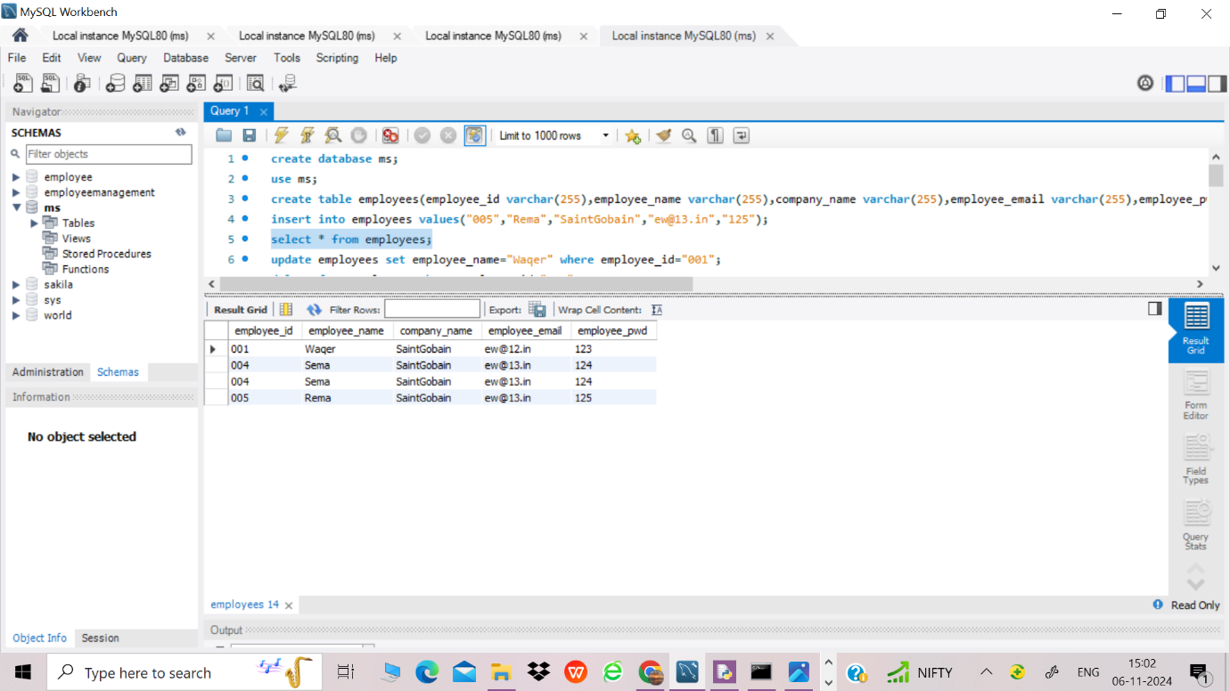



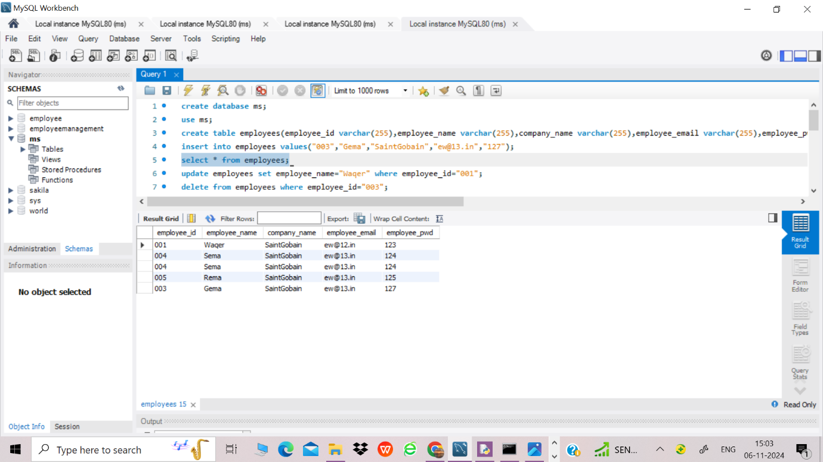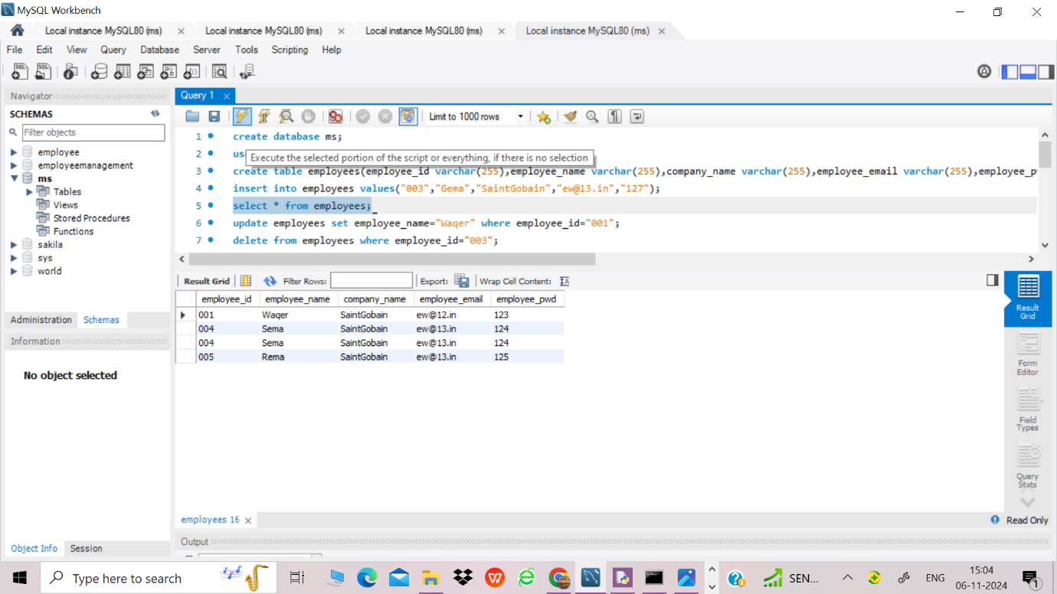



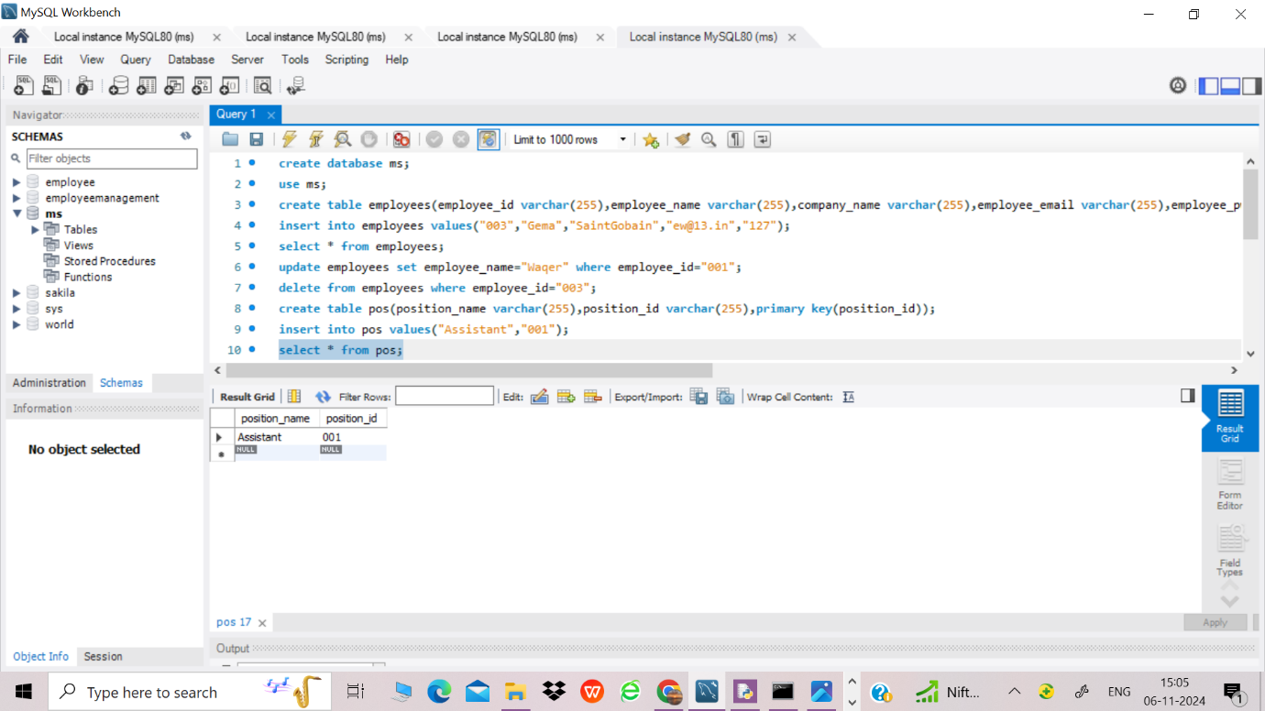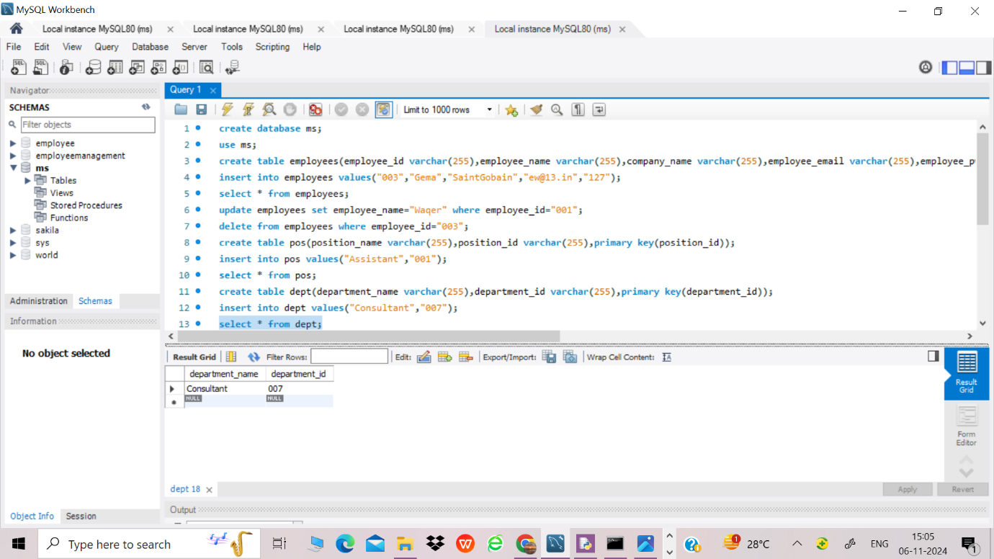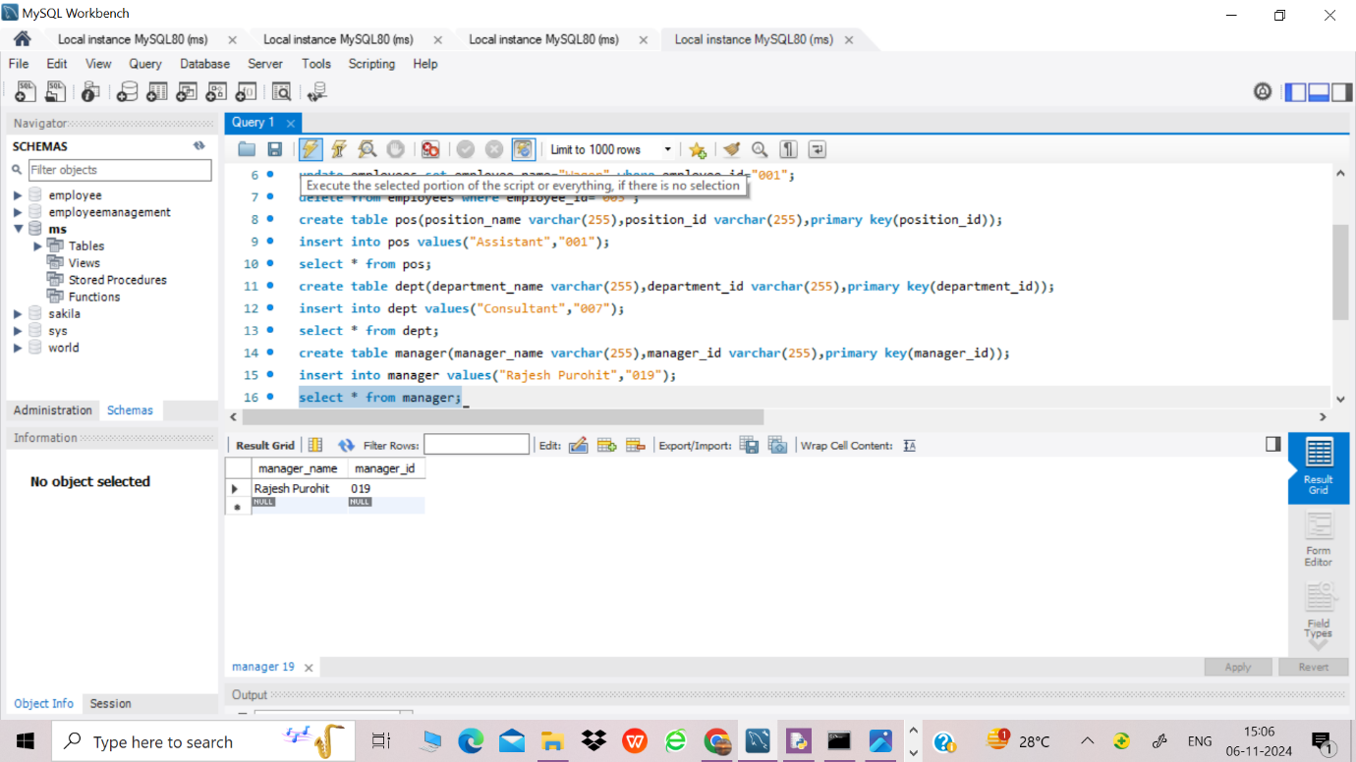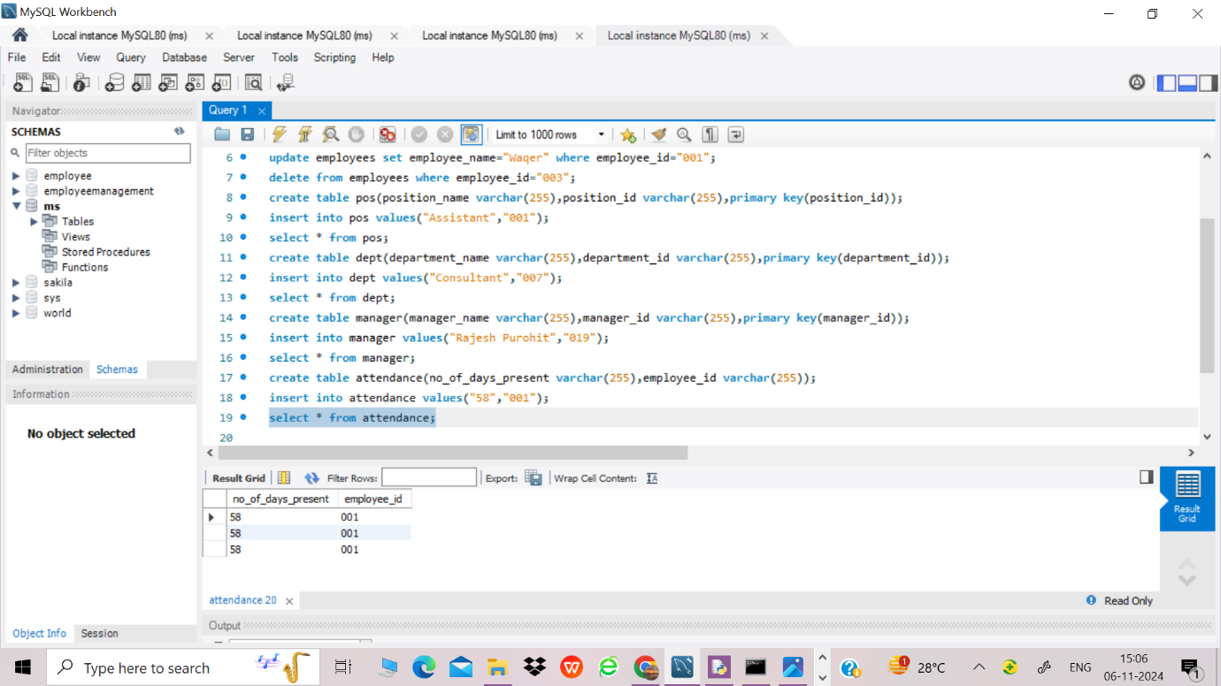

4)IDLE python code

import mysql.connector

mydb=mysql.connector.connect(host="localhost",user="root",password="Raginee123@",database="ms")

#to retrieve data from database

c=mydb.cursor()

c.execute("select * from employees")

for r in c:

print (r)

c2=mydb.cursor()

c2.execute("select * from pos")

for r in c2:

print (r)

#to insert data from database

eid=input("Enter employee ID: ")

did=input("Enter no of days present: ")

c3=mydb.cursor()

c3.execute("insert into attendance value(%s,%s)",(did,eid))

mydb.commit()

print("Employee updated successfully")

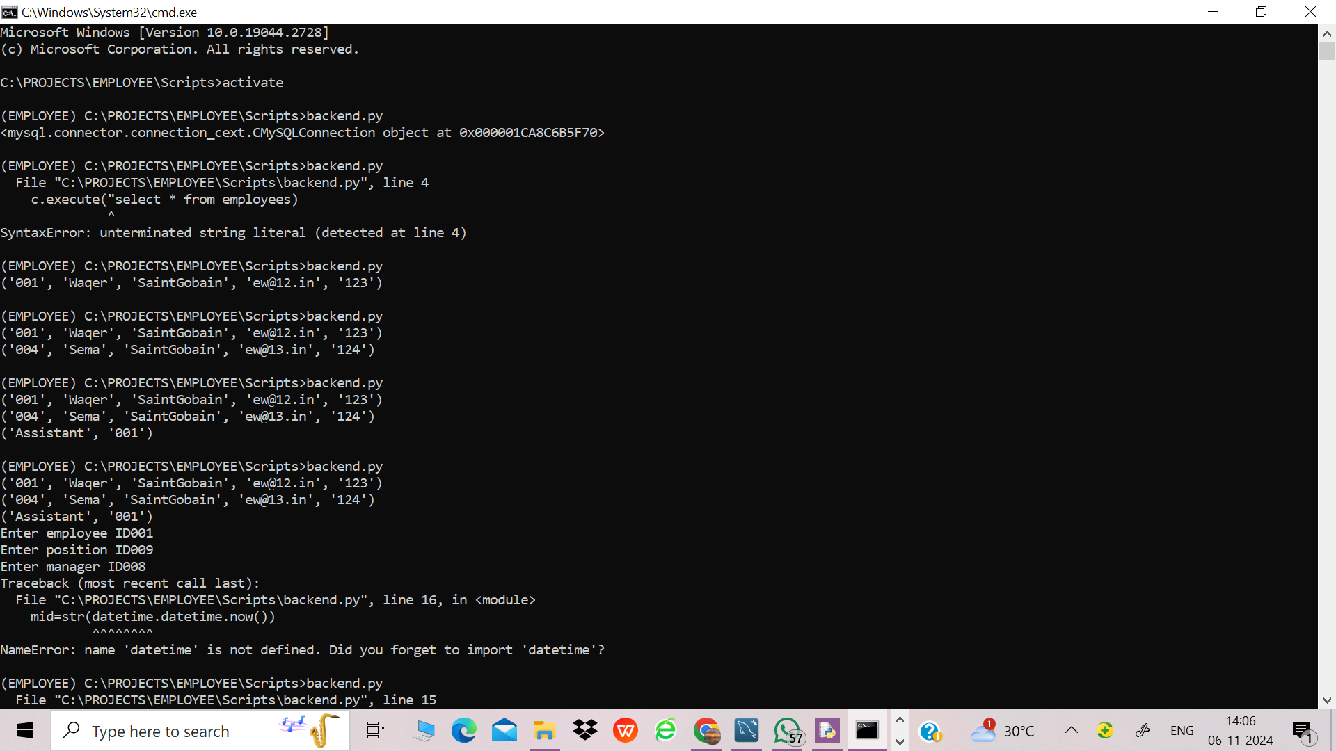

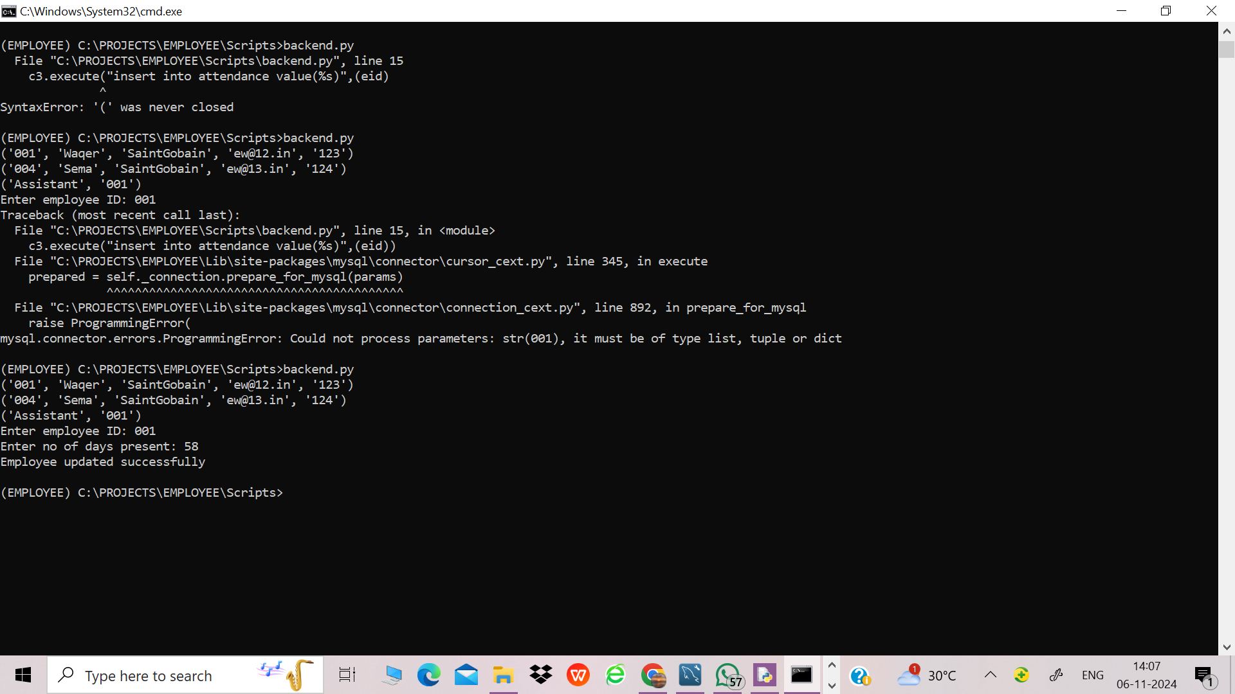

5)Streamlit python code

import streamlit as st

import pandas as pd

import mysql.connector

import datetime

st.title("EMPLOYEE MANAGEMENT SYSTEM")

choice=st.sidebar.selectbox("My Menu",("Home","User","Department"))

if(choice=="Home"):

st.image("https://img.freepik.com/free-vector/business-people-showing-document-client_1262-19209.jpg")

st.write("This is a web application developed by me")

elif(choice=="User"):

if 'login' not in st.session_state:

st.session_state['login']=False

eid=st.text_input("Enter Employee ID")

epwd=st.text_input("Enter password")

btn=st.button("Login")

if btn:

mydb=mysql.connector.connect(host="localhost",user="root",password="Ra45@",database="ems")

c=mydb.cursor()

c.execute("select * from employees")

for r in c:

if (r[0]==eid and r[4]==epwd):

st.session_state['login']=True

if(not st.session_state['login']):

st.write("Incorrect ID or Password")

if(st.session_state['login']):

st.write("Login Successful")

choice2=st.selectbox("Features",("None","View All Employees","Employees Update"))

if(choice2=="View All Employees"):

mydb=mysql.connector.connect(host="localhost",user="root",password="Ra45@",database="ems")

df=pd.read_sql("Select * from employees",mydb)

st.dataframe(df)

elif(choice2=="Employees Update"):

eid=st.text_input("Enter Employee ID: ")

did=st.text_input("Enter Departmaent ID: ")

btn2=st.button("Update")

if btn2:

jid=str(datetime.datetime.now())

mydb=mysql.connector.connect(host="localhost",user="root",password="Ra45@",database="ems")

c=mydb.cursor()

c.execute("insert into up values(%s,%s,%s)",(eid,did,jid))

mydb.commit()

st.header("Employee Updated Successfully")

elif(choice=="Department"):

if 'dlogin' not in st.session_state:

st.session_state['dlogin']=False

dept_id=st.text_input("Enter Department ID")

dept_name=st.text_input("Enter Department Name")

btn=st.button("Login")

if btn:

mydb=mysql.connector.connect(host="localhost",user="root",password="Ra45@",database="ems")

c=mydb.cursor()

c.execute("select * from deprt")

for r in c:

if (r[0]==dept_name and r[1]==dept_id):

st.session_state['dlogin']=True

if(not st.session_state['dlogin']):

st.write("Incorrect ID or Password")

if(st.session_state['dlogin']):

st.write("Login Successful")

choice2=st.selectbox("Features",("None","View All Departments","Add New Employee"))

if(choice2=="View All Departments"):

mydb=mysql.connector.connect(host="localhost",user="root",password="Ra45@",database="ems")

df=pd.read_sql("Select * from deprt",mydb)

st.dataframe(df)

elif(choice2=="Add New Employee"):

ename=st.text_input("Enter Employee name: ")

eid=st.text_input("Enter Employee ID: ")

cname=st.text_input("Enter Company name: ")

emname=st.text_input("Enter Employee Mail: ")

epwd=st.text_input("Enter password")

btn2=st.button("Add New Employee")

if btn2:

mydb=mysql.connector.connect(host="localhost",user="root",password="Ra45@",database="ems")

c=mydb.cursor()

c.execute("insert into employees values(%s,%s,%s,%s,%s)",(eid,ename,cname,emname,epwd))

mydb.commit()

st.header("Employee Added Successfully")

6)Screenshots of streamlit application

